W02 Assignment: Group Project

* A brief summary of the meeting content including a list of participants.

Andrey Gregorio Blanco Alfaro, Fernando Andres Cuba, Sean Sonderegger

For our first meeting we discussed best communication and meeting times outside our designated time. Our discussion entailed how our Handcrafted Haven app is going to function, creating a wireframe, and talked about design and useability. Skill strengths and a rough draft plan for tasks was also discussed.

* The URL of the group project's repo.

[fercub496/group7fullstack](https://github.com/fercub496/group7fullstack) – GitHub link

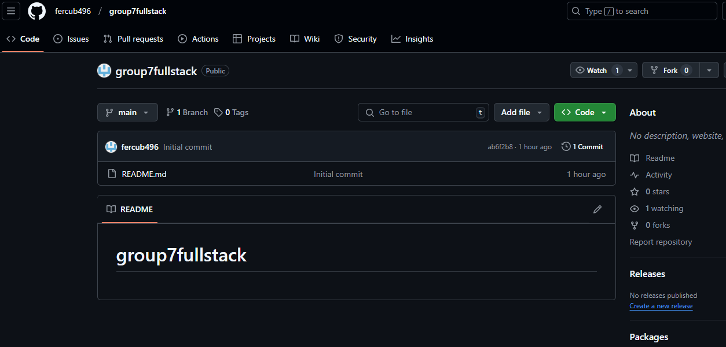

* A screenshot of their local group project that was cloned.

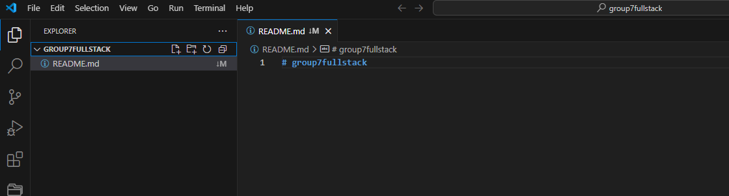

* Evidence of the design theme of the project.

[Web](https://byupathwayworldwideprod.sharepoint.com/sites/Course_wdd430-VJRRtpDBrODaQ/Shared%20Documents/Team%2007%20Thursdays%2000%2000%20UTC%200/handcrafted%20haven.pdf?CT=1741830657331&OR=ItemsView&wdOrigin=TEAMSFILE.FILEBROWSER.DOCUMENTLIBRARY) – web link

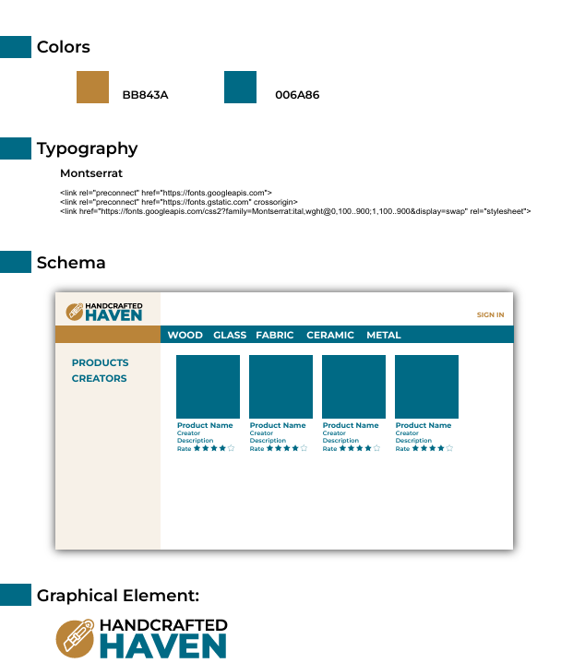

* Evidence of work item brainstorming. A minimum of 10 item titles with descriptions is required.

1. **Browse Product Listings**
   * Users can browse through a catalog of handcrafted items listed by artisans, viewing various products.
2. **Search for Products**
   * Users can search for specific products using keywords or product names.
3. **Filter Products by Category and Price**
   * Users can filter products based on categories (e.g., jewelry, home decor) and price ranges to find what they’re looking for.
4. **View Detailed Product Pages**
   * Users can view detailed pages for each product, including descriptions, pricing, images, and more.
5. **Leave Reviews and Ratings**
   * Users can rate products with a star system and write reviews to share their experiences with other shoppers.
6. **Create an Account and Log In**
   * Users can create an account, log in, and track their purchases, wish lists, and reviews.
7. **View Seller Profiles**
   * Users can visit individual seller profiles, where artisans showcase their products, share their stories, and highlight their craftsmanship.
8. **Add Products to Cart**
   * Users can add products to their cart for easy checkout and purchase.
9. **Proceed with Checkout and Payment**
   * Users can complete the checkout process, making payments for their purchases
10. **Interact with Product Reviews**
    * Users can read product reviews from other customers and even interact with the reviews by liking or flagging them if necessary